**The Echo Port**

# Aki Yoshida JA1NLX

## 1.0 GENERAL

~~The echo port was originally implemented in Logger32 version 3.50.121. With version 3.50.201,~~

~~a)~~ ~~the~~ The echo port can be configured to echo radio data to an external device (amplifier, or antenna, or whatever) that 'listens' on the port and follows the frequency/band. ~~or,~~ External device should use same CAT protocol as the radio.

~~b) the echo port can be configured to command a slave receiver (or transceiver) to follow the frequency and mode of the selected radio.~~

## 2.0 ECHO PORT SETUP

To configure the Echo Port, from the Logger32 Setup menu, select the Radio | Echo port configuration menu items.　”The Echo port repeats data to/from the selected radio only. No data is received on this port” option should be always checked if you use Eco port. The Logger32 COM port parameters, including RTS and DTR, should be configured as required for the radio or device being connected to the Echo Port.

~~a) If you want to use echo port which echo radio data to external device then check “The Echo Port repeats data...” option. Set port parameters and check Echo configuration options.~~

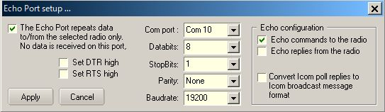

new TEP_1

~~b) If you want to use echo port which command a slave receiver (or transceiver) then check “The Echo Port synchronizes a slave receiver (or transceiver)...” option. Set port parameters and Slave radio configuration. If necessary you can configure mode conversion plan in Radio Mode box and Slave Mode box.~~

~~If your transceiver reports both VFO A and VFO B frequency/mode in real time, you may uncheck “Slave follows VFO A” option to sync the slave receiver to VFO-B. Otherwise you should check this option.~~

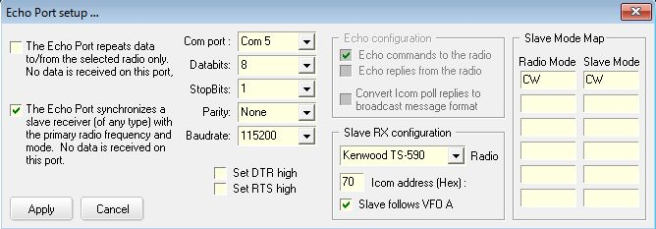

<Remove this picture>

~~TEP_2~~

The port is opened/closed by right clicking the Radio pane on the Lower Status bar or select the Logger 32 Setup menu Radio | Open(Close) port-Echo menu items.

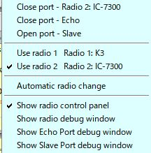

new TEP_3

The Echo Port state, open or closed, is shown on the Status bar of the Radio Debug window.

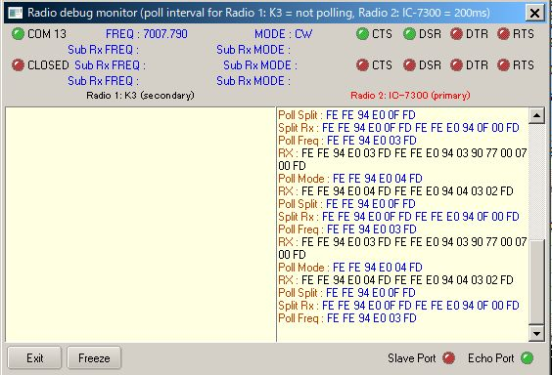

new TEP_4

You can see what command is sent to slave radio in Echo Port debug window.

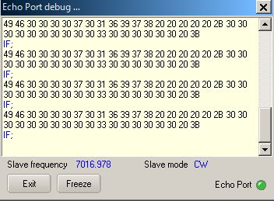

new TEP_5

## 3.0 EXAMPLES

~~The Logger32 COM port parameters, including~~ ~~RTS~~ ~~and~~ ~~DTR~~~~, should be configured as required for the radio or device being connected to the Echo Port.~~

### ~~3.1 Type a) Examples~~

~~These are examples when “The Echo Port repeats data.....” option is checked.~~

For the examples below, a K3 is connected to Logger32 using Com 2 and a TS-590SG is connected to the Echo port on COM1.

### ~~3.1.1~~ TS590SG is controlled by Echo replies from the radio (K3 in this case)

Check the Echo replies from the radio check box in the Echo port setup dialog box (TEP_1).

The following Macros in the Radio Control Panel will control the the TS590SG via Echo port;

* + - $command FA;$   read current K3 VFO A frequency and control TS590SG to this frequency; and
    - $command MD;$  read current K3 mode and control TS590SG to this mode.

**~~Note~~**~~: Both radios have the same command to set/read frequency and mode.~~

### ~~3.1.2.~~ TS590SG is controlled by Echo command to the radio

Check Echo commands to the radio in Echo port setup setup dialog box (TEP_1).

The following Macro in the Radio Control Panel will control both the K3 and TS590SG:

$command FA00014040000;MD3;$  set K3 and TS590SG to 14040.0KHz CW

**~~Note~~**~~: Both radios have the same command to set/read frequency and mode.~~

### ~~3.1.3.~~ K2 is controlled through Echo Port as second receiver of TS-590SG

When you click om a DX spot then both radios are tuned to that frequency. When you turn the TS-590SG VFO knob you must send specific command, FA; to TS590SG. K2 is tuned to same frequency as TS-590SG. This command is configured in one of function buttons in RCP.

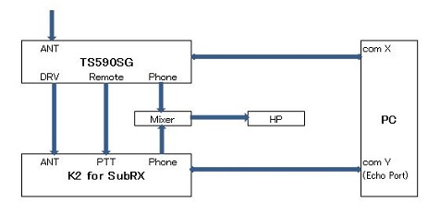

TEP_6

**~~Note~~**~~: This method is applicable for all transceivers only if both radios use the same CAT command protocol.~~

**IC-7300 is controlled through Echo Port as second reciver of anothor IC-7300**

IC-7300 #2 connected to Echo port follow anther IC-7300 #1 frequency and mode when DX Spot is clicked, frequency is typed in Logbook Entry Window or direct command to change frequecy and mode is trigerred.

In this case when you want to call rare station click DX spot or type his frequency. Both #1 and #2 IC-7300 are tuned to this frequency. While you listen to him on IC-7300 #2 look for clear frequenct to call him tuning IC-7300 #1 VFO. Just give a call on IC7300 #1.

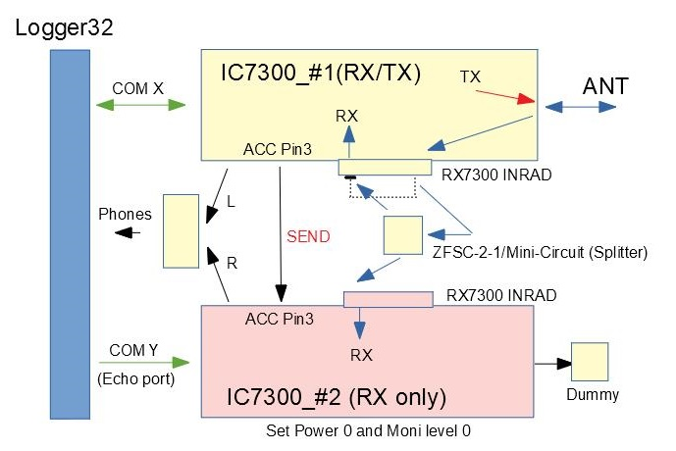

TEP_6A

### ~~(1) Logger32 setup steps~~

### ~~(1)-a TS-590SG setup~~

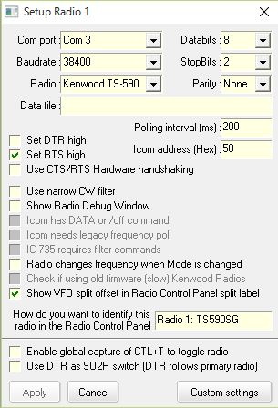

<Remove this picture>

~~TEP_7~~

<Remove all below>

### ~~(1)-b Echo port setup for K2~~

~~Click Setup in the main menu, click Radio and click Echo port configuration.~~

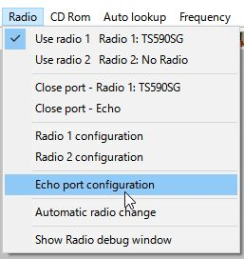

~~TEP_8~~

~~Select Com port which is connected to K2. “Echo commands to the radio” and “Echo replies from the radio” options should be checked.~~

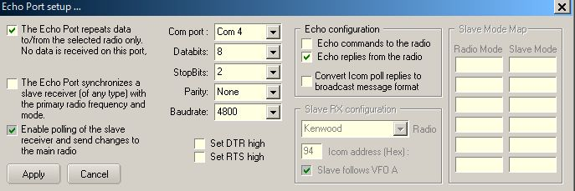

~~TEP_9~~

### ~~(1)-c RCP setup~~

~~When you click DX spot with split comment then both radios should not turn in split mode. For this purpose “Enable Set Split Macro when clicking on a DX Spot” option should be unchecked.~~

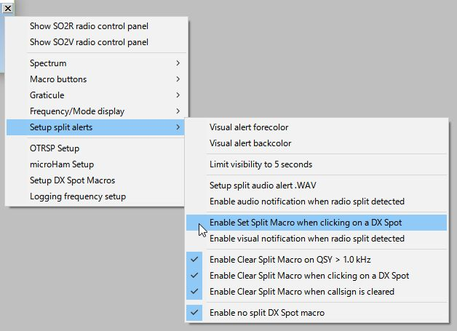

~~TEP_10~~

~~When you turn TS-590SG VFO knob then K2 VFO frequency is not changed. To tune K2 frequency FA; command is implemented in a function button in RCP.~~

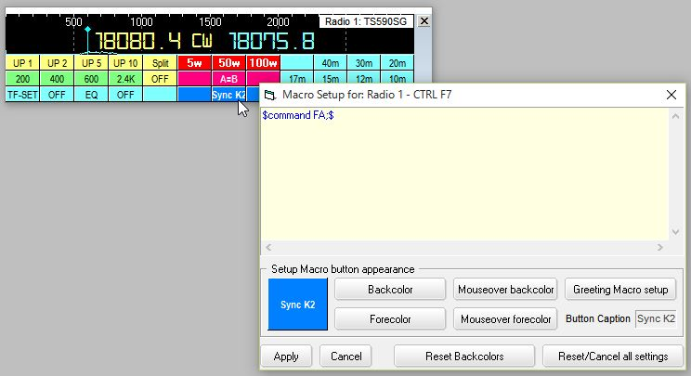

~~TEP_11~~

### ~~3.2 Type b) examples~~

~~These are examples when “The Echo Port synchronizes a slave receiver (or transceiver)...” option is checked. and “Enable polling of the slave receiver......” option is unchecked.~~

### ~~3.2.1 IC-7000 setup~~

~~For the example below, IC-7000 is connected to Logger32 using Com 7 and a TS-590SG is connected to the Echo port on COM3 as slave transceiver. If you turn IC-7000 VFO knob or click DX spot then TS-590SG is synchronized to this frequency/mode.~~

~~As you see this method is applicable for all transceivers which Logger32 supports.~~

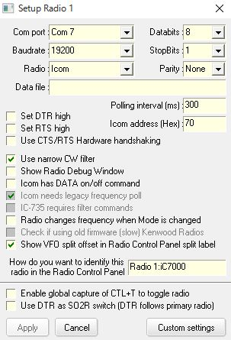

~~TEP_12~~

~~Echo Port setup for TS-590SG as slave transceiver~~

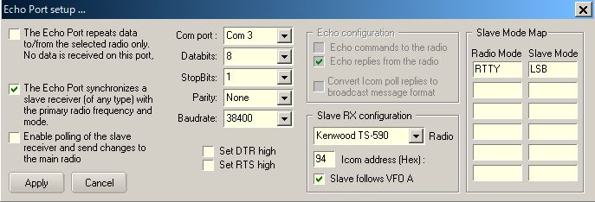

~~TEP_13~~

**~~3.2.2 Yaesu FT-920 setup~~**

~~The following example shows the setup for a FT-920 with an IC-735 as a slave transceiver.~~

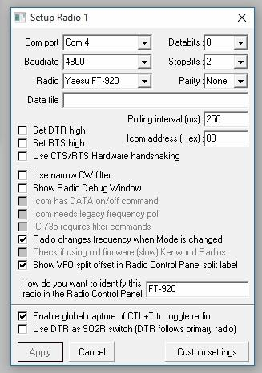

~~TEP_14~~

**~~3.2.3 Icom IC-735 setup~~**

~~The right hand side shows the radio Mode conversion.~~

**~~Note~~**~~: The baud rate is shown as 1200 (factory default). The radio can be set to 9600 with a jumper change.~~

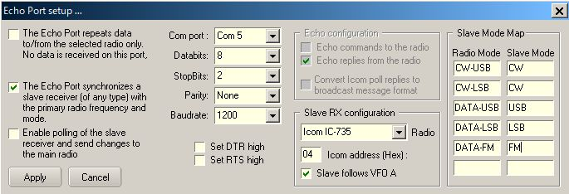

~~TEP_15~~